WEBSITE DEVELOPMENT

Part of GMC-simulator regarding website did not changed much compared to the previous version. Website level by analogy with product quality estimation is also determined not by fixed number of stars (1, 2, 3, 4, 5), but numerically. But in contrast to the product quality estimation, sheet “W” with original data for management report does not contain such information.

**Stars**

Series of tests showed that level of the website (number of stars) depends only on investments in website development, other factors do not affect or their influence is insignificant. Searching exact formula for calculating the number of stars from investments failed, but it is not the key to understand website development. Optimal investment strategy for the website development can be easily found by tests or brute force management reports.

**Minimums**

Each website level requires exact investments in website development to maintain achieved website level. In other words, there is a minimum of investment. For example, if we have 5* website and invest in next periods 20 or 30, then website level will fall to 4*, etc. Minimums (may vary by +/- 1 for particular scenario):

1．1* - 1

2．2* - 2

3．3* - 6

4．4* - 15

5．5* - 40

**Website development Influence on sales**

Website development affects only on sales in the Internet. Effect comes in the current period, but depends on competitors in the group. For example, if you are the only one in group of 8 teams who have invested in the website development, you get big increasing in sales than in the group where all your competitors have also invested in the website development.

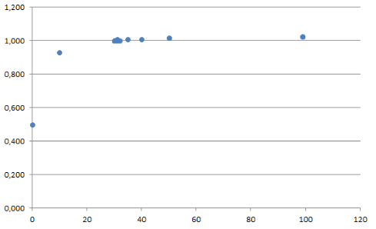

Influence on demand from website development is presented on diagram, like a power function. Growth of demand practically ceases after 35-40 and further increasing of website development practically has no effect on demand. Number of stars of website does not influence on demand and serves only as an indicator of website development spent in previous periods.

**Bonus**

Investments plan for website on scenario 12C1 (39 is for holding 5* website only on scenario 12C1, for remaining is 40):

1．1 period - 57 (5*), 2-5 period - 39 (5*) = 213 for 5 periods

2．1 period - 44 (4*), 2 period - 44 (5*), 3-5 period - 39 (5*) = 205 for 5 periods

**Hints**

1．On demand only affects amount of investment in website development.

2．The number of stars of the website does not influence on demand.

网站建设

关于网站的GMC模拟器的一部分与以前的版本相比没有多大变化。 网站级别与产品质量估算类比也不是由固定数量的星星（1,2,3,4,5）确定的，而是数字上确定的。但与产品质量估算相反，带有管理报告原始数据的表格W不包含此类信息。

**星级**

一系列测试表明，网站的级别（星星数量）只取决于对网站开发的投资，其他因素不影响或影响力不大。 搜索从投资计算星星数量的精确公式失败，但不是了解网站开发的关键。 网站开发的最佳投资策略可以通过测试或暴力管理报告轻松发现。

**最低**

每个网站级别需要对网站开发进行准确的投资，以保持网站的实现水平。 换句话说，投资最少。 例如，如果我们有5 *网站并在下一个20或30个时期投资，那么网站级别将降至4 *等。最小值（对于特定情况可能会有+/- 1）：

1．1* - 1

2．2* - 2

3．3* - 6

4．4* - 15

5．5* - 40

**网站开发影响销售**

网站开发仅影响互联网上的销售。效果在当前时期，但取决于集团中的竞争对手。例如，如果您是投资于网站开发的8个团队中的唯一一个，您的销售额将大大增加，而所有竞争对手也参与了网站开发。



网站开发对需求的影响如图所示，就像电力功能一样。 35-40之间的需求增长实际上已经停止，网站发展的进一步增长实际上对需求没有影响。 网站的星号不影响需求，仅作为以前期间网站开发的指标。

**奖励**

场景12C1网站投资计划（39个仅用于场景12C1持有5 *网站，剩余40个）:

1．第一期－57 (5*)，第二~五期－39 (5*) = 213合计五期

2．第一期－44 (4*)，第二期－44 (5*)，第三~五期－39 (5*) = 205合计五期

**提示**

1．需求仅影响网站开发投资。

2．网站上的星星数量不会影响到需求。